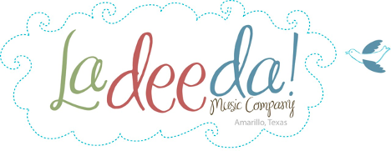
Lesson guide & resources
“Water, Water Everywhere!”
Escape to a musical island where lively rhythms
mingle with breezy tunes at the shore.

Ladeeda @ Home ~ Class Video 1
ACTIVITIES: Songs, stories, dances, rhymes,
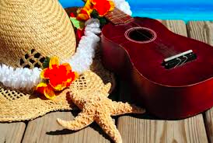
wave drum and rest
Bring the wonder of
music into your
home or program

Looking for music experiences?
Engage younger learners with easy activities and
high quality music-centered resources. Multicultural
and intergenerational. No music skills needed.
Sing songs, tell stories and let the music move you!

Celeste Pine, MT | LadeedaMusicCompany.com
Overview
Children at this age are learning music skills, motor and social-emotional skills as well as building empathy for each other and animals in the natural world. Help your child grow these skills and more as you sing, play and dance, make their own wave drum and hear an engaging story about a smiling fish.
Choose one or all the activities, any order you wish.

Focus question
What kinds of things would you see, do, smell, feel and hear at a pond, lake, ocean or river? Help your child explore ideas and ask questions. As they discuss, help older children record things they talk about and things they wonder on a piece of paper or in a notebook. They can draw illustrations, try their best to spell or you can write down what they dictate. Share with your child that musicians, artists and scientists do this all the time – they notice and wonder about the world.

Ages
3 - 6+ yrs Invite open-ended play, discovery, discussion. Interactment and observing are both ok.
Tots Invite open-ended play, discovery, describing. Interactment and observing are both ok.
0-14 mo Adapt the activities with focus on lovely experiences in sensory enrichment, conversation,
interactment, rocking/bouncing, dancing, bonding.

Follow the child's natural personality, their way of being and learning. This may sometimes have you modeling
the activity and being playful while they watch.

Video duration
31:10 Pause often to enjoy the moment, explore and improv!

Materials
Instruments if you have them.

Found objects can be instruments too like a box, laundry basket, container filled with anything (rice/beans/sand/?), kitchen instruments, your ideas?

Body percussion is fun too (clap, pat, swish).

Streamers or scarves for movement activities, or ribbons or colorful kitchen towels work well. Whatever you have is fine!

Wave Drum craft Paper or plastic plates. Tape – box tape or duct tape suggested. Crayons, colored pencils, markers, paints, stickers, or your ideas. Beads, cereal, pasta, sand or similar fillers.

Internet-connected device to view the video and view the suggested links or listen to music selections.

Preparation

10 minutes Make a simple Wave Drum to show the children. See video @ 24:55

Celeste Pine, MT | LadeedaMusicCompany.com
Procedure
Part one: Before the video
Develop background knowledge
Ask children if they've seen water creatures at a lake, pone, stream or ocean? Discuss what
they saw. Read a picture book about different water creatures including sea life.

Part two: Let's make music!
Prepare the children to take an imaginary musical adventure to the beach!

Songs
Row your boat 1:55
Sit down sister 5:24
Walk and stop 10:21
Story Time 13:29
Book: Fish with the Deep Sea Smile :)
by Margaret Wise Brown, Illustrated by Henry Fisher
Rhyme 18:33
Here are the Waves
Wave Drums
Meet the drums 23:29
Wave Drum craft 24:55
Rest Time 29:06
Pause and Breathe
Music link here: The Aquarium | Camille Saint Saens

Return to the focus question
Enjoy remembering the times you shared making music together today. What moments & activities did you enjoy?

Celeste Pine, MT | LadeedaMusicCompany.com

Rhyme---Here are the Waves
Here are the waves, the waves in the sea
Here is a boat, and here is me.

All the fishes down below

Wiggle their fins and away they go.

Enjoy a musical day!

Celeste Pine, MT | LadeedaMusicCompany.com

