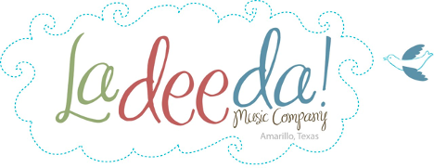
Lesson guide & resources
“Water, Water Everywhere!”
Escape to a musical island where lively rhythms
mingle with breezy tunes at the shore.

Ladeeda @ Home ~ Class Video 2
ACTIVITIES: pretend boat rides, Boom Bang rhyme,
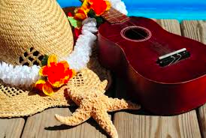
meet the instruments, story song “Going Over the Sea”
Bring the wonder of
music into your
home or program

Looking for music experiences?
Engage younger learners with easy activities and
high quality music-centered resources. Multicultural
and intergenerational. No music skills needed.
Sing songs, tell stories and let the music move you!

Celeste Pine, MT | LadeedaMusicCompany.com
Overview
Children at this age are learning music skills, motor and social-emotional skills as well as language, listening and pretend play. Help your child grow these skills and more as you say fun rhymes, take imaginary adventures with singing sailors on a boat, and meet interesting instruments.
Choose one or all the activities, any order you wish.

Focus question
If you could take a boat trip, where would you go? Would you take along a friend or family
member?

As they discuss, help older children record things they talk about and things they wonder on a
piece of paper or in a notebook. They can draw illustrations, try their best to spell or you can
write down what they dictate. Share with your child that musicians, artists and scientists do
this all the time – they notice and wonder about the world.

Ages
3 - 6+ yrs Invite open-ended play, discovery, discussion. Interactment and observing are both ok.
Tots Invite open-ended play, discovery, describing. Interactment and observing are both ok.
0-14 mo Adapt the activities with focus on lovely experiences in sensory enrichment, conversation,
interactment, rocking/bouncing, dancing, bonding.

Follow the child's natural personality, their way of being and learning. This may sometimes have you modeling
the activity and being playful while they watch.

Video duration
27:45 Pause often to enjoy the moment, explore and improv!

Materials
Instruments if you have them.

Found objects can be instruments too like a box, laundry basket, container filled with anything (rice/beans/sand/?), kitchen instruments, your ideas?

Body percussion is fun too (clap, pat, swish).

Streamers or scarves for movement activities, or ribbons or colorful kitchen towels work well. Whatever you have is fine!

Pretend boat ride small box for 1-2 or more stuffed animals. Or a bigger box for your child to sit in as their boat. Towel, blanket, scarves or sparkle material for pretend water. Decorations for your boat, if you wish.

Internet-connected device to view the video and view the suggested links or listen to music selections.

Preparation

15 minutes Decorate your boat, if you wish.

Procedure
Part one: Before the video
Develop background knowledge
Ask children if they've seen different kinds of boats (name a few: canoe, row boat, speed boat, tugboat, ship). Discuss what they saw. Read a picture book about boats.

Part two: Let's make music!
Prepare the children to take an imaginary musical adventure to the beach!

Songs
Row your boat 3:22
Two in the boat 6:33
Move to the beat 8:35

Rhyme 10:37
Boom Bang

Dance, Listen and
Instrument Play 13:00
Sit Down Sister
Instruments: djembe, clave, guiro and bamboo windchime

Story Time Song 18:38
Song: “Going Over the Sea”
1. ukulele “had some fun”
2. washboard “tied my shoe”
3. tambourine “drank some tea”
4. guiro “open the door”
5. clave “swam and dived” or “took a dive”
6. triangle “pick up sticks”
7. maracas “baked in the oven”
8. vibraslap “learned to skate”
9. zipper “doing fine!”
10. glockenspiel “do it again!”

Rest Time 24:41
Pause and Breathe
Music The Water us Wide | Little Hands

Return to the focus question
Enjoy remembering the times you shared making music together today. What moments & activities did you enjoy?

Celeste Pine, MT | LadeedaMusicCompany.com

Rhyme--- Boom Bang, Boom Bang
Boom bang, boom bang
Rumpety lumpety bump.
Zoom zam, zoom, zam,
Clippity cloppety clump!

Enjoy a musical day!

Celeste Pine, MT | LadeedaMusicCompany.com

